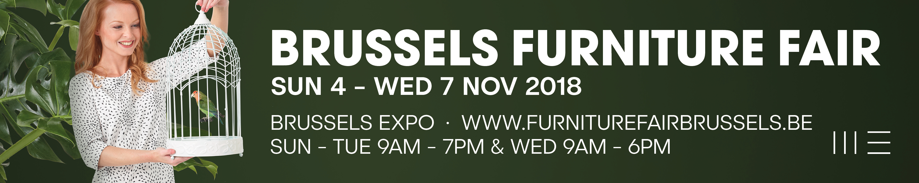

Preview Brussels Furniture Fair 2018
The beautiful summer days are gone, and the leaves are beginning to fall from the trees. For the European furniture sector, this means it’s time to prepare for one of the most important international events of the year: the Brussels Furniture Fair. Traditionally, this is where the Belgian furniture industry shows its latest collections to an international audience. But Brussels is not only important for the Belgians: its more than 60% foreign exhibitors are also looking forward to a face-to-face contact with the visitors. Brussels is not just a fair where people come and look around. Real business is being done here. Together with the Brussels Furniture Fair’s highly convivial atmosphere, this makes Brussels the place to be.

Brussels is not a gigantic fair, but is still a considerable size. So thorough preparation can make your visit a lot easier. The website is the ideal tool for this. Not only can you consult the exhibitors’ list online, but you can also use it to mark your favourites and export them into a personalized list. On the interactive floor plan, you can see which exhibitor is on what stand, and thus work out your own route. It goes without saying that you can easily navigate the website from your smartphone. So looking up something at the fair itself is still possible.

A clear segmentation of the offering
What’s more, the fair is composed of different segments, each with its own style. This makes it easier for visitors to navigate the fair efficiently. City is the largest segment, and shown in halls 3, 4 and 5. With its contemporary furniture offering, it represents the core of the market. Here you can find the major Belgian manufacturers, but the Dutch, Germans and Italians are also well represented. So for those looking for a sofa manufacturer, modern chairs and tables, or modern cupboards and wardrobes, City is the place to be. Square in hall 3 shows furniture collections with even purer lines. This is the segment for affordable design. Specialists in bedroom comfort should head for Brussels by Night in hall 6, with a large offering of beds, box springs and mattresses. Apart from bedroom comfort, bed textiles are well represented too. This is logical, because a retailer needs both! Apart from this, there is a zone for the contract market: Hospitality World. The exhibitors here show ready-made concepts for fitters of hotel rooms, bed & breakfasts, restaurants and even apartments.
For cosier presentations, Fusion is where you want to be. Warm materials, industrial vintage look, individual armchairs and side tables, solid wood furniture, chesterfields, etc. You find it all in hall 8. The offering is supplemented by decorative pieces that can also give an extra touch to the presentation in the shop. A well-presented collection quite simply sells better!
Mozaïek is the name for collections at affordable prices, and is shown in hall 9. But it’s not just the price that matters here. There’s also more and more attention being paid to good design and trendy models.
Finally, Holland à la Carte in the Patio does not feature a specific style of furniture. Instead, you can find a selection of strong Dutch manufacturers. With furniture, sofas, tables and chairs, cushions, lighting and even tapestries on offer, this is a hall that’s definitely worth a visit!

Experience and atmosphere
The Brussels Furniture Fair would not be itself without its well-known convivial atmosphere. With a fresh campaign image, we’ll be bringing back the spring in autumn. Once inside, the autumnal weather is easily forgotten! For a refreshing break, you can stop at one of the free bars with surprising food concepts. Coffee, tea, soft drinks and beer are available all day. In the morning, fresh croissants are served, and at noon there’s soup, sandwiches and a range of original dishes. And in the afternoon there’s something small to go with a cup of coffee. If you want something more, you can always visit the restaurant above the entrance of hall 5, where a quick and affordable lunch is served. And for moments when the food in the bars is finished, the Be Shop still has something to offer. Elaborate dining is reserved for the evening, when you hit the city centre. If you don’t really know where to go, check the website for a selection of bars and restaurants at all price levels. The list is split up per quarter of town, so you can definitely find something nice near your hotel!

Tuesday evening is traditionally when the Balthazars are awarded. With these trophies, the Brussels Furniture Fair wants to put some exhibitors in the spotlight with a remarkable innovation or an original collection. At a festive awards ceremony, the winners receive a certificate and of course also the highly coveted Balthazar: a 12-litre bottle of champagne! At the reception afterwards, a toast can be proposed to the winners.

Inspiration can be found on numerous gorgeous stands, but also in our trend showcases between the halls. Every year, art director Siegrid Demyttenaere distils a few trends. This year, they were given the common title “Get in touch”. Especially in times of digitization, people are looking to connect with each other again. Furniture can create the right setting for that. We also seek connection with how our things are made. Storytelling is essential in the selling process, both for manufacturers and retailers. And we are focusing more on beautiful materials. To make these trends more concrete, they are illustrated with a selection from the exhibitors’ offering. These give you an extra opportunity to discover a new manufacturer, of can inspire you for the set-up in your shop. This year the presentation of the trends is being completely transformed and shown in a far more airy setting!

Even though we are an international fair, we do not forget that our roots lie with the Belgian furniture industry. That’s why the Brussels Furniture Fair gives them some extra attention in its BE Magazine. In this magazine, you’ll find a preview of the new collections the Belgians will be exhibiting at the fair. And there are certainly some pleasant surprises! The magazine illustrates the resilience and creativity of the Belgian furniture sector. It piques your curiosity. An article and a picture are one thing, but to see the piece of furniture for real is something else.

Get in touch
The title of the trends not only clearly indicates what people need nowadays, but is also the central function of a trade fair. A fair is all about encounters, experiences, and seeing and touching the latest collections for real. And so, the Brussels Furniture Fair is an important event in the European trade fair calendar. A trade fair visit is always enriching. Even if you don’t have immediate intentions to buy, it is still interesting to have a look. In a short time, you get an update on the offering and can talk directly to the makers of the collections that will soon be on the shop floor. In a direct contact, you also discover the story behind these collections. And this is something Pinterest or Instagram cannot replace. Although these are definitely interesting tools, they cannot replace human contact just like that. Facilitating encounters between manufacturers and buyers is what the Brussels Furniture Fair aims to do. And we strive to do this in a pleasant atmosphere and in an efficient way, so that a visit to the Brussels Furniture Fair is also really rewarding!

Lieven Van den Heede
Brussels Furniture Fair 2018
4 - 7 November
9 am - 7 pm (on Wednesday until 6 pm)
www.furniturefairbrussels.be

