Preview Brussels Furniture Fair 2021

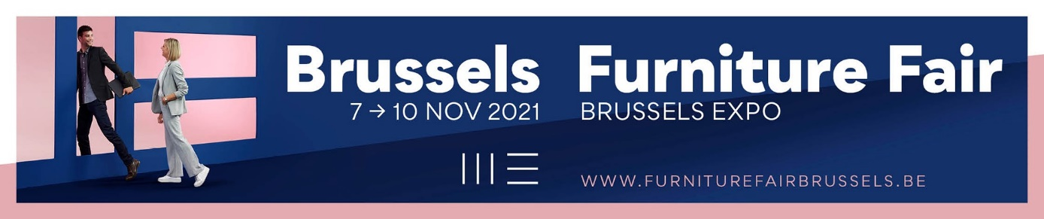

Welcome back to Brussels!!

After a year without a trade fair – you’ve guessed it: coronavirus – we’re finally looking forward to throwing open our doors again to exhibitors and visitors from our neighbouring countries and the rest of Europe. Over the past two years, it’s become clear that the digital realm can replace many things, but that physical trade fairs are still a core part of trade. Especially for furniture. Looking, touching and testing out are all so much easier in real life. A trade fair brings together all the collections for the coming furniture year in one place, which makes it easy for buyers to make their selection. From the enthusiasm shown by manufacturers and the furniture trade, it’s already clear how much the Brussels Furniture Fair is appreciated and how sorely the fair was missed. Naturally, that’s great to hear.

So after a difficult period, we’re finally bringing the furniture trade and manufactures back together again. What’s more, the fair will be pleasingly well-attended, with a great selection to choose from. Due to its shorter lead time, the fair is a little smaller than usual, but it’s still very much worth a visit. In fact, alongside the familiar exhibitors, there are a striking number of newcomers this year.

In order to simplify visitors’ search and ensure that the manufacturers meet the right clientele, as always the exhibitors are grouped into clear segments. Are you looking for contemporary, modern furniture? Then City in halls 3, 4 and 5 is the place to start your visit. The market leaders of the Belgian furniture industry are proudly on display in the imposing hall 5, and you’ll find strong international manufacturers in halls 3 and 4. Looking for something slightly sleeker? Then you’ll find affordable design in hall 3 in Square. Perhaps the country or industrial style is more your thing? Then be sure to take a look at Fusion, in hall 8. In Holland à la Carte in the Patio both styles come together. The common thread here is the Dutch manufacturer. For sleep specialists there is one-stop-shopping in hall 6. Brussels by Night showcases a variety of Belgian and international manufacturers with both technical innovations and stylish sleeping concepts. And finally, for budget-friendly furniture you can visit Mozaïek in hall 9.

Thorough preparation for your fair visit allows you more time for discoveries at the fair itself. At www.furniturefairbrussels.be you’ll find a clear list of all exhibitors. You can sort them by nationality, by hall or by segment. Contract specialists, for example, are visiting the fair in ever greater numbers. So it’s handy for them to only see those manufacturers that specialise in the contract market. A single click and the selection is made! What’s more, to refine your selection still further you can mark all the manufactures you want to visit and export them in a handy list. Armed with your list, you don’t need to miss anything at the fair itself. Shortly prior to the fair, a clickable floorplan will be made available online. But it would be a shame to base your visit on your pre-selections alone. Feel free to walk into a stand that you’re not familiar with and allow yourself to be surprised. After two years without trade fairs, there are certain to be plenty of new things to discover! And yes, even if you don’t buy, you’re still welcome.

Because we haven’t yet shaken off coronavirus entirely, there will still be a few measures in place during the fair to ensure that everything can take place safely. You definitely need to print out your entrance ticket in advance this year. This will prevent too many people crowding together in the entrance halls. What’s more, the QR-code of your Covid Safe Ticket will be scanned. This works with all European formats, just like when you travel. With the Covid Safe Ticket you’ll be allowed access to the fair. This means that you’ve either been fully vaccinated, have proof of a recent negative PCR test or approved pharmacy-administered antigen test, or have recently recovered from coronavirus. Whilst face masks are no longer obligatory, they are still recommended.

The convivial welcome you’ll receive at the Brussels Furniture Fair will feel reassuringly familiar this year. A range of bars will welcome you with a drink and a snack, which is offered free of charge. So treat yourself to a delicious cup of coffee or a glass of Belgian beer. A fresh croissant will fill any remaining gap you might have in the morning, and at lunchtime you can enjoy soup, a filled baguette or one of the small, original dishes on offer.

A visit to the Brussels Furniture Fair often goes hand in hand with an overnight stay in our capital city. Belgians love delicious dining and drinking. So it will come as no surprise that at a culinary level, Brussels has a great deal to offer. Not entirely sure where to go? On the Furniture Fair website you’ll find a selection of our favourite restaurants and bars in all price categories. That’s part and parcel of an enjoyable trade fair visit too!

In the passages between the halls, we’d normally be showcasing the style trends. But the pandemic has shaken everything up. We’ve become aware that sustainability is important. So this year, instead of short-term trends, we’ll be showcasing products that focus on the long term. These might be products that use eco-friendly materials, a timeless design, or a circular business model. So get inspired by our exhibitors’ models as you walk from one hall to another.

On Tuesday evening, 9 November, we’ll once again be handing out the Balthazars. These awards are designed to put unusual innovations, original designs or inspiring collections in the spotlight. At our festive ceremony, the winners will receive a giant bottle of champagne. The champagne will also be flowing freely at this ideal networking moment for exhibitors and visitors alike.

A warm welcome back to the Brussels Furniture Fair!

Lieven Van den Heede
Brussels Furniture Fair
7-10 November 2021
9 am -7 pm (on Wednesday till 6 pm)
www.furniturefairbrussels.be

